Cloud Computing – Assignment 2

**Title:** Deploy a website on the AWS EC2.

**Objective:** To understand the working of Amazon EC2 Linux AMI.

**Problem Statement:** Deploy a Website on the AWS EC2 instance.

**Software Requirements:** Browser (Chrome/Firefox), Amazon EC2instance**.**

**Hardware Requirements:** Laptop/Desktop, internet connection **Theory:**



**Amazon Elastic Compute Cloud (Amazon EC2)** providesscalable computing capacity in the Amazon Web Services (AWS) cloud. Using Amazon EC2 eliminates your need to invest in hardware up front, so you can develop and deploy applications faster. You can use Amazon EC2 to launch as

many or as few virtual servers as you need, configure security and networking, and manage storage. Amazon EC2 enables you to scale up or down to handle changes in requirements or spikes in popularity, reducing your need to forecast traffic.

**Features of Amazon EC2**

* Amazon EC2 provides the following features:
* Virtual computing environments, known as instances
* Preconfigured templates for your instances, known as Amazon Machine Images (AMIs), that package the bits you need for your server (including the operating system and additional software)
* Various configurations of CPU, memory, storage, and networking capacity for your instances, known as instance types
* Secure login information for your instances using key pairs (AWS stores the public key, and you store the private key in a secure place)
* Storage volumes for temporary data that's deleted when you stop or terminate your instance, known as instance store volumes

* Persistent storage volumes for your data using Amazon Elastic Block Store (Amazon EBS), known as Amazon EBS volumes
* Multiple physical locations for your resources, such as instances and Amazon EBS volumes, known as Regions and Availability Zones
* A firewall that enables you to specify the protocols, ports, and source IP ranges that can reach your instances using security groups
* Static IPv4 addresses for dynamic cloud computing, known as Elastic IP addresses
* Metadata, known as tags, that you can create and assign to your Amazon EC2 resources
* Virtual networks you can create that are logically isolated from the rest of the AWS cloud, and that you can optionally connect to your own network, known as virtual private clouds (VPCs)

**Instances and AMIs:**

An Amazon Machine Image (AMI) is a template that contains a software configuration (for example, an operating system, an application server, and applications). From an AMI, you launch an instance, which is a copy of the AMI running as a virtual server in the cloud. You can launch multiple instances of an AMI, as shown in the following figure

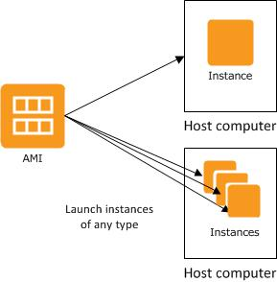

**Related Steps and Screenshots**

